**MATERIALS SCIENCE**

**SCIENCE OLYMPIAD**

**Directions:**

You may use ONE nonprogrammable calculator. Answer all questions in the test book. Show your work or calculations when necessary. A periodic table is included as the last page of this test.

**Team Name: __________________________________ Team Number: ________________**

**A. Creep of Materials**

1. The creep curve for a typical metal is shown in the figure below.

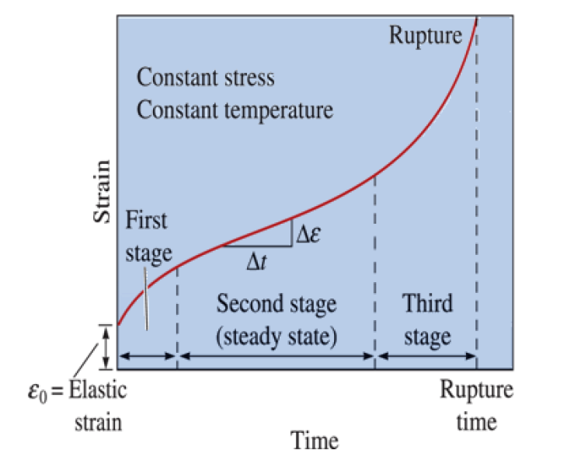

2. Which condition likely caused this metal to “creep”?

a. Salt water conditions

b. High weight

c. Cryogenic conditions

d. High temperatures

3. In the first stage of creep, the creep rate decreases with increasing time. What is the scientific origin of this behavior?

a. Elastic deformation

b. Strain hardening

c. Annealing

d. Fracture

4. The metal melts at 1240°C. Estimate the temperature above which creep will occur.

a. 413°C

b. 1240°C

c. 231°C

d. 504°C

**B. Stiffness of material**

5. Which class of materials generally has the highest Young’s Modulus?

a. Metals

b. Polymers

c. Ceramics

d. Composites

Question 6-8 makes use of the figure below, which shows a stress-strain curve for an unknown material.

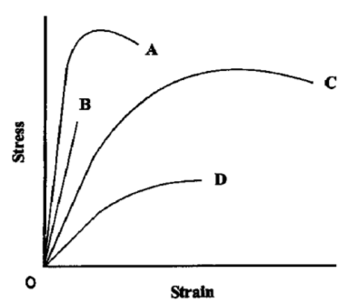

6. Based on this data, which material is brittle?

a. Material A

b. Material B

c. Material C

d. Material D

7. Based on this data, which material is ductile?

a. Material A

b. Material B

c. Material C

d. Material D

8. Based on this data, which material is the stiffest?

a. Material A

b. Material B

c. Material C

d. Material D

9. Which of the following has the highest Young’s Modulus:

a. Aluminum

b. Diamond

c. Pine

d. Rubber

**C. General properties and material characterization**

10. Which of the following materials is a ceramic?

a. Aluminum reinforced with silicon carbide particles.

b. Polytetrafluoroethylene (“Teflon”)

c. Silicon carbide

d. Carbon fiber reinforced epoxy

11. Which of the following materials is a polymer?

a. Aluminum reinforced with silicon carbide particles.

b. Carbon fiber reinforced epoxy

c. Copper

d. Teflon

12. Which of the following materials is a composite

a. Transparent Sapphire.

b. Carbon fiber reinforced epoxy

c. Copper

d. Teflon

13. Yield strength is defined as the strength at which a material

a. Experiences tensile failure

b. Fails under cyclic loading

c. Fails under a suddenly applied load

d. Experiences permanent deformation

14. Calcium has an atomic number Z=20. The electron configuration for a Magnesium ion with a +2 charge is:

a. 1s22s22p63s23p64s2

b. 1s22s23s23p64s2

c. 1s22s22p63s23p6

d. 1s22s22p63s23p64s23d2

15. Modern bronze is made of

a. Copper and zinc

b. Copper and silver

c. Copper and magnesium

d. Copper and tin

16. Modern Steel is made of

a. Iron and copper

b. Iron and silicon

c. Copper and carbon

d. Iron and carbon

17. What would be the hybridization in a single bond between C-F in a molecule of CF4?

a. s-sp3

b. s-sp2

c. p-sp2

d. p-sp3

18. If a viscous fluid flows steadily in a pipe, the fluid speed

a. Is the same at the pipe wall and center, but is smaller in between.

b. Is the same at the pipe wall and center, but is greater in between.

c. Is greatest near the pipe wall, but decreases toward the center.

d. Must be uniform across any cross section.

19. An experiment was performed that measured the flow rate of four different liquids as the temperature was increased.

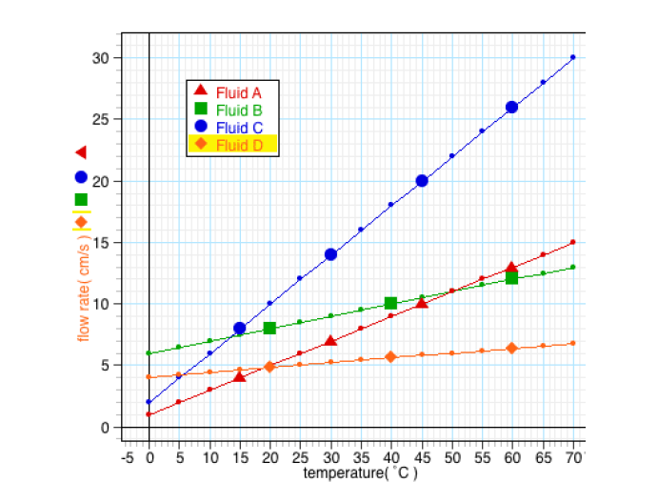

20. According to the graph, which of the liquids had the greatest viscosity at a temperature of 30°C?

a. Fluid A

b. Fluid B

c. Fluid C

d. Fluid D

**Part II: Intermolecular Forces and Surface Chemistry**

The figure below shows the atomic arrangement in graphite. Use this figure to answer problems 21 and 22.

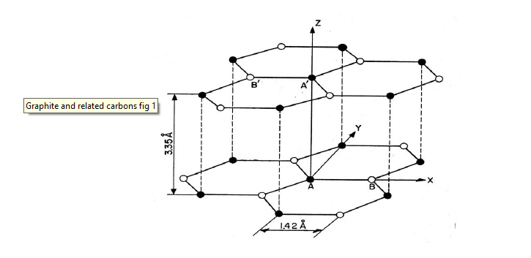

21. Which of the following explains why graphite is a good solid lubricant?

a. In-plane bonding in graphite is only van der Waals’ forces.

b. Out-of-plane bonding in graphite is only van der Waals’ forces.

c. In-plane bonding in graphite is covalent and metallic.

d. Out-of-plane bonding in graphite is covalent and metallic.

22. Which of the following explains why graphite is a good electrical conductor?

a. In-plane bonding in graphite is only van der Waals’ forces.

b. Out-of-plane bonding in graphite is only van der Waals’ forces.

c. In-plane bonding in graphite is covalent and metallic.

d. Out-of-plane bonding in graphite is covalent and metallic.

23. What is the coordination number for the Body-Centered Cubic (BCC) structure?

a. 6

b. 8

c. 10

d. 12

24. What is the shape of the primitive unit cell of the Body-Centered Cubic (BCC) structure?

a. Cubic

b. Tetragonal

c. Rhombohedral

d. Hexagonal

25. The figure below shows octahedral coordination, in which six nearest atoms of radius R surround an atom of radius r, with R being larger than r. This coordination is often known as the rock-salt structure and is found in compounds such as sodium chloride.

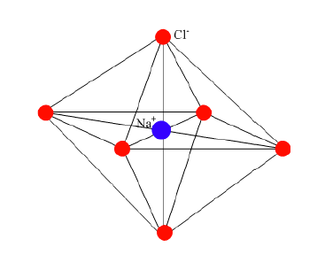

Calculate the minimum r/R ratio for this coordination to be stable. Show your calculations below:

*Hint*: Use the following diagram.

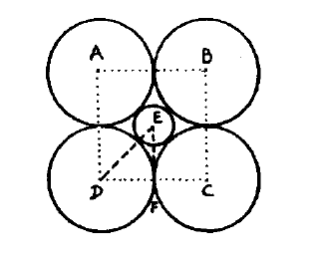

26. On what Bravais lattice is the structure in problem 25 based?

a. FCC

b. BCC

c. HCP

d. HCP

27. The reason that vacancies are always present in the lattice is

a. They are equilibrium defects.

b. Crystals are not perfect.

c. They are easy to form.

d. There is an activation energy for their formation.

28. If a liquid wets the surface it falls on (like water on glass), what is the approximate contact angle?

a. Less than 90°

b. Exactly 180°

c. More than 90°

d. 45°

29. The bonding between the molecules of liquid hydrogen is

a. Hydrogen bonding.

b. Network bonding.

c. Van der Waals’ forces.

d. Non-polar bonding.

30. The adhesion of a gas or liquid to a surface is called

a. Adsorption.

b. Bonding.

c. Meniscus.

d. Absorption.

31. As water temperature increases from 0°C to 100°C, what happens to the surface tension?

a. Increases

b. Decreases

c. Stays the same

32. The body-centered cubic (BCC) and face-centered cubic (FCC) latties

a. Have different packing factors.

b. Both contain close-packed planes.

c. Have the same stacking sequences of the close-packed planes.

d. All of the above.

33. Hexagonal Close Packed (HCP) metals include

a. Magnesium.

b. Zinc.

c. Titanium.

d. All of the above.

34. The number of atoms in a unit cell of BCC, FCC, and HCP metals are

a. 4, 2, 6 respectively

b. 6, 4, 2 respectively

c. 2, 4, 6 respectively

d. None of the above

Use the following information to answer questions 35 and 36:

**Copper exhibits the FCC structure. Its atomic radius is 1.28 Å.**

35. Calculate the lattice constant (in Å) of copper, i.e., the length of an edge of the conventional cubic unit cell.

36. Calculate the packing factor of copper, i.e., the fraction of space that is occupied by atoms.

37. Give the Miller indices of the family of close-packed planes in copper. Use the conventional notation for indicating a family of planes (e.g. {0 0 0}).

38. What causes the different physical properties between graphite and diamond?

a. Diamond is harder.

b. Location where each is formed.

c. Internal arrangement of carbon and hydrogen atoms.

d. Internal arrangement of carbon atoms.

39. The figure below shows a molecule of Polyvinyl Chloride (PVC).

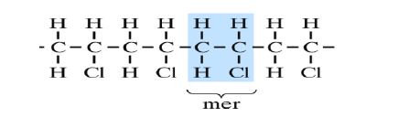

A molecule of PE is the same in composition as that of PVC except that each Cl (chlorine) atom is replaced by an H (hydrogen) atom. Which of the following best explains why PVC is stiffer than PE?

a. PE exhibits ionic bonding, while PVC exhibits covalent bonding.

b. Hydrogen bonding occurs in PVC.

c. Hydrogen is lighter than chlorine, so PE is less dense than PVC.

d. PVC tends to form longer chains than PVC.

40. Four sigma bonds emanate from the central atom “M” to four atoms of element “X”. What is the most probably structure for the compound MX4?

a. Tetrahedral

b. Trigonal pyramidal

c. Planar

d. Octahedral

41. An element with 3 terminal atoms around a central atom with one lone pair of electrons on the central atom is most likely which structure (MX3):

a. Tetrahedral

b. Trigonal pyramidal

c. Planar

d. Octahedral

42. What allows the molecular flexibility of an organic polymer?

a. Alternating single and double bonds between the carbon atoms

b. Single bonds involving a single pair of electrons

c. Multiple covalent bonds involving two or more electron pairs

d. Triple bonded carbon atoms

43. Which of the following materials would most likely be an amorphous material?

a. silica cooled rapidly from its molten state

b. sapphire cooled slowly from its molten state

c. aluminum cooled slowly from its molten state

d. sapphire cooled quickly from its molten state.